**Assignment No 1**

**Name :** DARIAN DAJI

**Roll No.:** 3164018

**Class :** TE-A

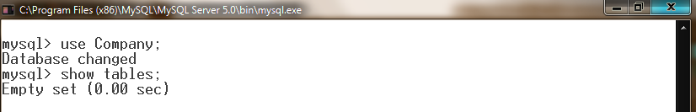

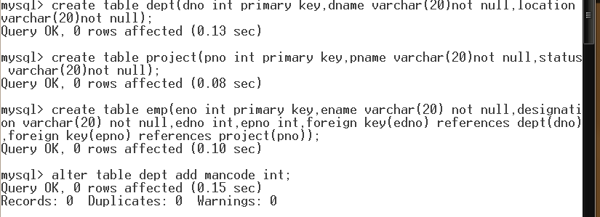

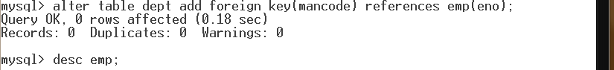

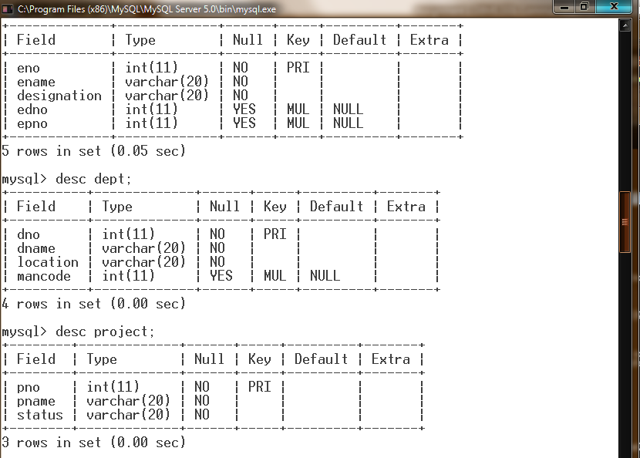



**DCL Commands:**

**Root Window :**

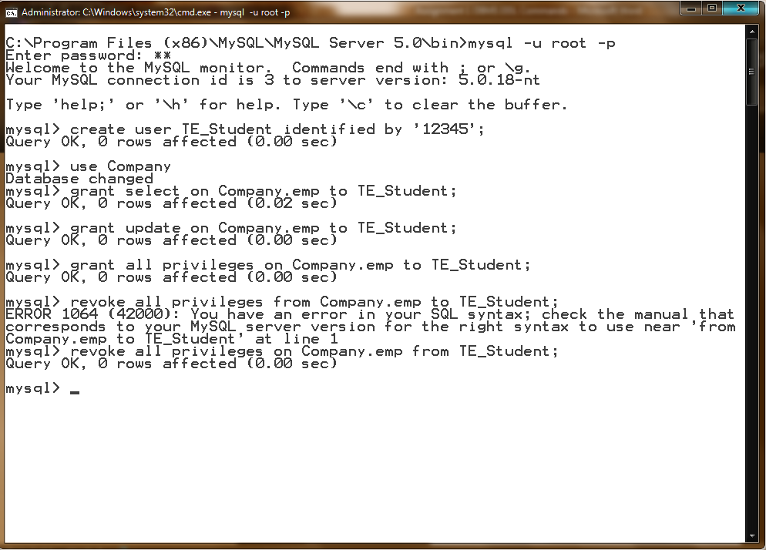

**TE_Student Window :**

